**POWER BI USER GUIDE**

**CHAPTER 1 INTRO:**









Power BI - Git hub link:

<https://github.com/IterationInsights/Microsoft-Press-Introduction-to-Microsoft-Power-BI-V2>

**CHAPTER 2 : Importing Data & Power Query**

* **Data Preparation**: As a data analyst, a significant portion of your work involves preparing data for analysis, which includes tasks like removing rows and columns, cleaning data, and merging datasets.
* **Power Query Capabilities**: Power Query simplifies and automates data ingestion and transformation, offering features like data connectors, intuitive data shaping, and recorded transformations to save time.
* **Efficiency**: Using Power Query can potentially reduce data preparation time by up to 80%, making the process more efficient and less manual.

The **M language** is a powerful data transformation language used in Power Query. It allows you to perform complex data manipulations and transformations efficiently. In Power Query, M language records the steps you take to transform your data, making it easier to automate and repeat these processes. This helps streamline data preparation and ensures consistency in your data models.





















**ETL IN POWER BI:**



**MERGE QUERIES:**



**MERGING IN POWER BI:**

* **Purpose of Merging: Merging the product and product rollup queries helps reduce the number of tables, making the data model less intimidating and more efficient for end-user self-service. It also improves performance and allows for building hierarchies within the data model.**
* **Steps to Merge:**
  + **Select the product query and use the "Merge Queries" function.**
  + **Choose the product rollup query to merge with the product query.**
  + **Match the columns (e.g., Product Subcategory) and select the type of join (default is left outer join).**
  + **Expand the merged table to include only the necessary columns.**
* **Benefits: Merging queries simplifies the data model, enhances performance, and supports building hierarchies, which is crucial for creating comprehensive and organized reports.**

**Reducing the number of tables in a data model has several benefits:**

* **Simplification: Fewer tables make the model less intimidating and more approachable for end users, facilitating self-service.**
* **Performance: It can improve performance by reducing the complexity of the data model.**
* **Hierarchies**: It allows for the creation of hierarchies, as all columns participating in a hierarchy need to exist in the same table.

**FOLDER CONNECT**

* **Using the Folder Connector**: The video explains how to use the folder connector in Power BI to import multiple files from a directory as if they were a single file, which simplifies the data import process.
* **Consistency in Data Format**: It emphasizes the importance of having a consistent data format across all files to ensure smooth data transformation and avoid errors.
* **Automation Benefits**: By maintaining standards and consistent formats, new data files can be automatically integrated into the Power BI model without additional manual adjustments, enabling efficient automation.

The folder connector in Power BI allows you to treat multiple files within a folder as a single data source. This is particularly useful when you have data spread across multiple files and want to apply the same transformation to all of them. By using the folder connector, you can:

* Combine data from multiple files into one query.
* Apply consistent transformations across all files.
* Simplify data management by treating all files as a single entity.

This is especially beneficial when dealing with large datasets or when new files are added regularly, as it automates the process and ensures consistency.

To import data from a folder in Power BI, follow these steps:

1. **Open Power BI Desktop**: Start by opening your Power BI Desktop application.
2. **Navigate to Power Query Editor**: Click on the "Home" tab and then select "Transform Data" to open the Power Query Editor.
3. **Select New Source**: In the Power Query Editor, click on "New Source" and then select "More" to open the Get Data dialog box.
4. **Choose Folder Connector**: In the Get Data dialog box, find and select the "Folder" connector, then click "Connect".
5. **Browse for Folder**: Click "Browse" to navigate to the folder containing your data files. Select the folder and click "OK".
6. **Combine and Transform Data**: After selecting the folder, you will see a list of files within it. Click "Combine" and then "Combine & Transform Data".
7. **Select Sample File**: In the dialog box that appears, choose a sample file to define the structure of the data. Ensure all files in the folder follow the same structure.
8. **Select Data to Import**: Choose the table or data object you want to import from the sample file. Ensure all files have the same table structure.
9. **Skip Files with Errors (Optional)**: You can choose to skip files with errors by checking the appropriate box. If unchecked, the entire load will fail if any file does not match the structure.
10. **Finalize Import**: Click "OK" to import and combine the data from all files in the folder into a single query.
11. **Rename Query (Optional)**: You can rename the query for better clarity by right-clicking on the query name and selecting "Rename".
12. **Clean Up Data**: Perform any necessary data cleaning, such as removing unnecessary columns or changing data types.
13. **Load Data**: Once you are satisfied with the data, click "Close & Apply" to load the data into Power BI.
14. These steps will help you import and combine data from multiple files in a folder into Power BI.

**UPPEND DATA (Combine the data in two different sheet in to a single sheet)**

The "Append sale queries" exercise is designed to combine sales data from different sources into a single table, which is crucial for comprehensive data analysis. Here are the advantages and a step-by-step explanation of the process:  
  
Advantages:

* **Unified Data Analysis**: By combining sales data from different countries into one table, you can perform global sales analysis more efficiently.
* **Consistency**: Ensures that all sales data is in a consistent format, making it easier to work with and analyze.
* **Flexibility**: Power Query is flexible in handling different data types and column mismatches, making the data preparation process smoother.

Step-by-Step Process:

1. **Load Data**: Load all the data from your sources through the Power Query editor.
2. **Identify Tables**: Identify the tables you want to combine (e.g., United States sales and other countries' sales).
3. **Append Queries**:  
   * Go to the Power Query editor.
   * Select the table you want to append to (e.g., other countries' sales).
   * Click on the "Combine" menu and choose "Append".
   * Select "Append as new" to create a new query.
   * Choose the tables to append (e.g., other countries' sales and United States sales).
4. **Rename Query**: Rename the new query to something meaningful (e.g., "Sales").
5. **Check Columns**: Ensure that the columns match and handle any mismatches (e.g., columns with different names or missing columns).
6. **Adjust Data Types**: Make sure the data types are consistent and adjust them as needed.
7. **Remove Unnecessary Columns**: Remove any columns that are not needed (e.g., the "freight" column if it's not present in all tables).
8. **Finalize Data**: Ensure that the final table has the correct column names and data types.

This process helps in creating a unified dataset that can be used for more effective and comprehensive data analysis.

When appending queries in Power BI, column mismatches are handled by matching columns based on their names. Here are the key points:

* **Column Matching**: Power BI matches columns purely based on their names, regardless of data types.
* **Missing Columns**: If a column exists in one query but not the other, Power BI will create the missing column and fill it with null values for the rows from the query that lacks the column.
* **User Intervention**: You can then decide how to handle these null values or remove the mismatched column if it's not needed.

This approach ensures flexibility while allowing you to manage any discrepancies in the data.

**CREATING A NEW COLUMN (as multiplied values of other two columns)**

In the "Create columns", the function used to multiply values from two columns is the Multiply function. Here's how it's done:

1. Select the two columns you want to multiply (e.g., Order Quantity and Unit Price).
2. Go to the Add Column tab.
3. In the Standard group of functions, select Multiply.

This will create a new column with the multiplied values from the selected columns.

**CHAPTER 3:**

**DATA MODELING AND CLEAN UP**

The process described in the "Model loading and cleanup" helps improve efficiency in several ways:

* **Reduces Data Model Size**: By removing unnecessary tables (like other country's sales, United States sales, and product rollup), you reduce the size of your data model, which can improve performance and speed.
* **Optimizes Performance**: Excluding irrelevant data ensures that only essential information is processed, leading to faster query responses and more efficient data handling.
* **Improves Clarity**: Using staging tables helps keep the data model clean and organized, making it easier to manage and understand, which is crucial for effective data analysis and reporting.
* These steps collectively enhance the overall efficiency of your data model, making it more streamlined and responsive.

How It's Done:

1. **Identify Unnecessary Tables**: Determine which tables are no longer needed in the data model (e.g., other country's sales, United States sales, and product rollup).
2. **Enable Load Option**:  
   * Go to the Power Query Editor.
   * Right-click on the queries you don't want to load into the data model.
   * Select "Enable Load" to disable loading these tables.
   * Confirm the "Possible Data Loss Warning" if no reports are built on these tables.
3. **Load Data**: Click "Close and Apply" to load only the necessary tables into the data model.

Advantages:

* **Reduces Data Model Size**: By excluding unnecessary tables, the data model becomes smaller, which can improve performance and speed.
* **Optimizes Performance**: Processing only essential data leads to faster query responses and more efficient data handling.
* **Improves Clarity**: Keeping the data model clean and organized makes it easier to manage and understand, which is crucial for effective data analysis and reporting.

Summary:  
This process helps ensure that only the necessary data is included in your model, optimizing performance and clarity. It involves identifying and disabling the load for unnecessary tables, which reduces the size of the data model and enhances overall efficiency.

**DOCUMENTATION IN POWER BI**

* **Organize Queries into Groups**: Create groups such as Facts, Dimensions, and Staging to categorize your queries. This helps in managing and understanding your data model better.
* **Document Queries**: Add descriptions to queries and transformation steps to provide context for future reference. This is crucial for maintaining clarity and ensuring that others can understand and support your work.
* **Query Dependencies**: Use the Query Dependencies view to visualize how data sources and transformations are connected. This helps in understanding the data flow and relationships within your model.
* **Data Source Settings**: Access all data source settings in one place to manage and update data connections efficiently.
* **Advanced Editor**: View and edit the M code generated for your queries to understand the underlying transformations.

These practices help in maintaining a well-organized and documented Power Query environment, making it easier to manage and share your work.

To organize queries in Power Query, you can follow these steps:

1. **Create Groups**:  
     
   * Right-click in an empty spot in the Queries pane.
   * Select "New Group" and name it (e.g., Facts, Dimensions, Staging).
2. **Move Queries to Groups**:  
     
   * Right-click on a query, select "Move To Group," and choose the appropriate group.
   * Alternatively, you can drag and drop queries into the desired group.
3. **Document Queries**:  
   * Right-click on a query, select "Properties," and add a description to provide context for future reference.

This organization helps in managing and understanding your data model better.

**DATA MODELLING**

* Relationships
* Formatting
* Hierarchies
* DAX Functions & Formulas

**DIMENSIONAL MODELING:**





* Dimensional Modeling: This methodology centers around measuring business processes (facts) and describing those measurements using dimensions, forming a Star Schema or Dimensional Model.
* **Star Schema vs. Snowflake Schema**: A Star Schema has a single fact table in the center with dimension tables around it. A Snowflake Schema involves more complex structures with additional tables. For beginners, sticking with the Star Schema is recommended.
* **Benefits**: Dimensional models simplify data navigation, management, and consumption. They enable consistent analysis across an organization and are optimized for use in Power BI.  
  This approach can make your data analysis more efficient and consistent, especially useful in your role in data analysis.

**STAR SCHEMA:**

A Star Schema is a type of data modeling methodology used in data warehousing and business intelligence. It centers around measuring a business process, known as facts, and describing those measurements using dimensions.

* Fact Table: Contains the quantitative data about the business process (e.g., sales transactions).
* **Dimension Tables**: Contain descriptive attributes related to the facts (e.g., product, customer, date).

In a Star Schema, the fact table is at the center, and the dimension tables are connected to it, resembling a star. This structure makes data easier to navigate, manage, and analyze, which is particularly useful in tools like Power BI.



**SNOKE FLAKE SCHEMA:**

A Snowflake Schema is a type of data modeling methodology that is an extension of the Star Schema. In a Snowflake Schema, the dimension tables are normalized, meaning they are split into additional tables. This results in a more complex structure with multiple related tables.

For example:

* Instead of having all product information in one table, you might have a product table and a separate product category table.
* These tables are connected, creating a "snowflake" shape.

While the Star Schema is simpler and easier to navigate, the Snowflake Schema can be more efficient in certain scenarios, especially as you advance in your Power BI skills.





**CARDINALITY**















**DATA MODELLING:**

**MODIFY COLUMN PROPERTIES:**

* Data Categorization: Assign appropriate data categories (e.g., Country, City) to columns to help the data model understand the type of data.
* Formatting Numeric Columns: Set default formatting for numeric columns, such as currency or whole numbers, to ensure consistent presentation in reports.
* Default Summarizations: Define default summarization methods (e.g., Sum, Average, Do not summarize) for numeric columns to control how data is aggregated in reports.

These practices help improve the accuracy and usability of your Power BI reports.

1. **Data Categorization**:  
     
   * **Step**: Categorize columns (e.g., Sales Territory Country) as geographical data.
   * **Relevance**: Helps Power BI understand the nature of the data, improving reporting accuracy and functionality, especially for location-based data.
2. **Formatting Monetary Data**:  
     
   * **Step**: Format numeric columns (e.g., Line Total Sales) as currency.
   * **Relevance**: Ensures monetary values are displayed correctly, enhancing readability and consistency in reports.
3. **Setting Default Summarizations**:  
     
   * **Step**: Set default summarization for numeric columns (e.g., Yearly Income set to “Do not summarize”).
   * **Relevance**: Prevents inappropriate aggregations, ensuring data is summarized correctly in reports.

These steps are crucial for creating a well-structured data model in Power BI, which is essential for accurate and efficient data analysis and reporting. Proper categorization, formatting, and summarization settings make it easier to build and consume reports, ultimately aiding in better decision-making based on the data.

**OPTIMISING RELATIONSHIPS :**

* **Optimize Relationships**: Ensure relationships are built on numeric-based columns rather than text-based columns for better performance.
* **Use Power Query**: Utilize the merge functionality in Power Query to bring necessary keys into your tables to create optimal relationships.
* **Clean Up Data Model**: Remove unnecessary columns from your data model to keep it efficient and organized.

These steps help ensure your data model is optimized for better performance and easier management.

**Creating Column Group**

Grouping data in Power BI helps organize and simplify complex data for better analysis and reporting.

 First, you select the column and go to the relevant table, such as the sales territory column. Then, you open the column tools. Next, select the group button under the data groups section. Then add items to the group and select the items you want to put together, for instance, select Canada and click group, rename this group to North America. You can add more items and create additional groups for the process for other regions such as Europe and Australia and rename the columns to reflect the new group such as Sales Territory Continent.

**Creating Hierarchies**





**Use of Creating Hierarchies in Power BI:**

* **Improved Data Organization**: Hierarchies help organize data into logical levels, making it easier to navigate and analyze.
* **Enhanced Reporting**: They allow for more intuitive and detailed reporting, enabling users to drill down into specific data points.
* **Better Data Visualization**: Hierarchies improve the clarity and effectiveness of visualizations by structuring data in a meaningful way.

Creating hierarchies in Power BI helps streamline data analysis and enhances the overall user experience.

To create a product hierarchy in Power BI, follow these steps:

* 1. **Open Model View**: Switch to the Model View in Power BI.
  2. **Select Product Table**: Go to your Product table and ensure the Properties and Data panes are open.
  3. **Create Hierarchy**: Find the "Product Category" column, right-click on it, and select "Create Hierarchy." This will create a new hierarchy called "Product Category Hierarchy."
  4. **Rename Hierarchy**: Rename the hierarchy to something simpler, like "Product Hierarchy."
  5. **Add Levels**:
  + Ensure the Product Hierarchy is highlighted.
  + In the Properties pane, add the next levels by selecting "Product Subcategory" and "Product Name."
  + Click "Apply Level Changes" to save the hierarchy levels.
  1. **Hide Original Columns**: Hide the original columns (Product Category, Product Subcategory, and Product Name) to ensure they are only visible within the hierarchy.

This will create a structured product hierarchy, making it easier to analyze your data.

**Optimizing Relationships**

Optimizing relationships in Power BI is crucial because:  
  
**Performance**: Optimized relationships, especially those based on numeric columns rather than text, improve the performance of your data model. This leads to faster query processing and report generation.

* **Accuracy**: Ensuring relationships are correctly defined helps maintain data integrity and accuracy, which is essential for reliable analysis and reporting.
* **Efficiency**: By removing unnecessary columns and using appropriate keys, you reduce the data model's complexity, making it easier to manage and understand.

In your field, optimizing these relationships ensures that your data analysis is both efficient and accurate, leading to more reliable insights.

Using text-based columns (characters or words) for creating relationships in Power BI can lead to several issues:

* **Performance**: Text-based relationships can slow down the performance of your data model because text comparisons are generally slower than numeric comparisons.
* **Storage**: Text columns take up more storage space compared to numeric columns, which can make your data model larger and less efficient.
* **Consistency**: Text data can be prone to inconsistencies (e.g., typos, different cases), which can cause errors in relationships and lead to inaccurate data analysis.

In the video, it is demonstrated how to optimize relationships by converting text-based columns to numeric-based columns, which improves performance and ensures more reliable data relationships.

Text-based relationships in data models are less optimal because they can lead to performance issues. Numeric-based columns are generally faster to process and more efficient for building relationships. In the "Optimize relationships" video, it is explained that text-based columns can slow down data operations and take up more space in the data model. By using numeric keys, you ensure that relationships are more efficient and the data model performs better.

**Steps :**

1. **Identify Relationships**:
   * Look at the relationships between tables, such as between customer and sales, or sales territory and sales.
2. **Check Column Types**:
   * Ensure relationships are built on numeric columns. Text-based columns are not optimal.
3. **Open Power Query**:
   * Go to the Home tab and click on "Transform data" to open Power Query.
4. **Merge Tables**:
   * Select the Sales table, click on "Combine" and then "Merge".
   * Merge the Sales table with the Sales Territory table using the sales territory region as the matching column.
5. **Select Columns to Merge**:
   * In the table expander, select the Sales Territory Key column to add it to the Sales table.
6. **Remove Unnecessary Columns**:
   * After merging, remove the original text-based column (Sales Territory Region) from the Sales table.
7. **Apply Changes**:
   * Click "Close and apply" to save the changes and reload the data model.
8. **Rebuild Relationships**:
   * In the model view, **delete the old text-based relationship**.
   * Create a new relationship using the numeric Sales Territory Key.

This process ensures that all relationships are based on numeric columns, optimizing the performance of your data model.

**Data Model Clean up :**

In the session we "Discuss data model cleanup," two major options for data model cleanup are discussed:

1. **Remove Columns**: Completely remove unnecessary columns from the data model so they are no longer physically present. This helps in saving space and ensuring that these columns are not used in reports.
2. **Hide Columns**: Hide columns within the data model so they cannot be seen or used at report time. This is useful for columns that are needed for data structure but should not be visible to report writers.

These options help in optimizing the data model and making it more efficient for reporting.

Fact & Dimension Tables:

* **Fact Table**: This table contains the quantitative data for analysis. It includes numeric values and keys that relate to dimension tables. For example, in a sales data model, the fact table might include sales amounts, quantities, and keys like customer key, product key, and sales territory key.
* **Dimension Table**: This table contains descriptive attributes related to the facts. It provides context to the data in the fact table. For example, a customer dimension table might include customer names, addresses, and other relevant details.

In the "Discuss data model cleanup" video, the instructor talks about hiding key columns in the fact table to ensure that filtering is done through the dimension tables, maintaining efficient and accurate data analysis.

Filtering should be done using the dimension table rather than the fact table to maintain the integrity and efficiency of the data model. Here’s why:  
  
**Filter Direction**: Filters flow from dimension tables down to fact tables. This ensures that only relevant data is shown in the fact table based on the selected dimension values.

* **Efficiency**: Dimension tables are typically smaller and contain unique values, making them more efficient for filtering. Fact tables, on the other hand, are larger and contain repetitive data, which can slow down filtering processes.
* **Data Integrity**: By filtering through dimension tables, you ensure that the relationships and data integrity are maintained, preventing incorrect or partial data from being displayed.

**CHAPTER 4:**

**DAX Basics**

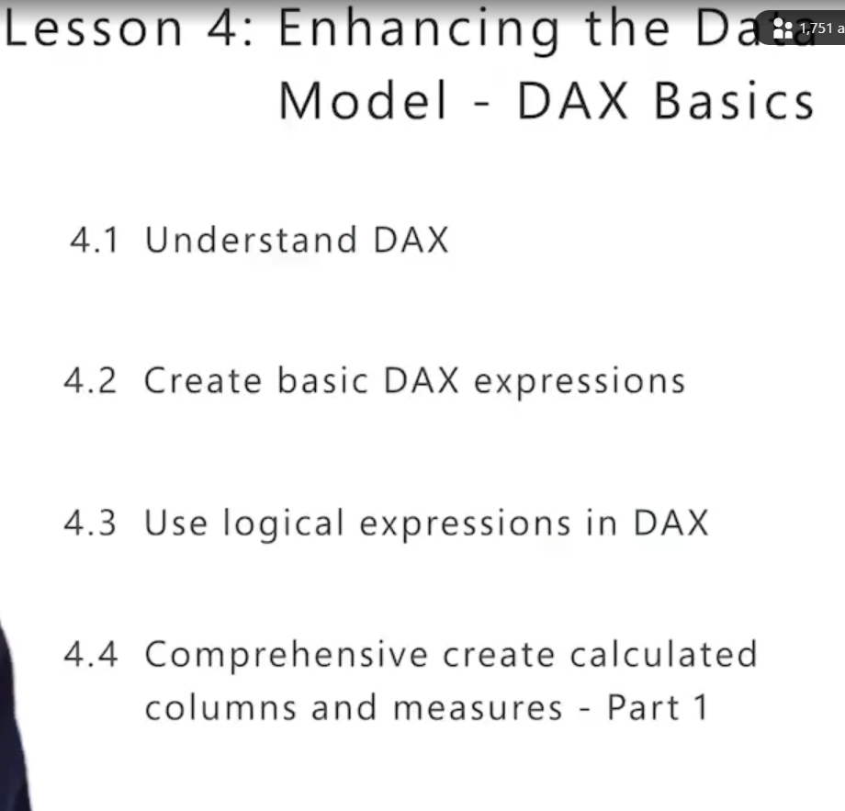

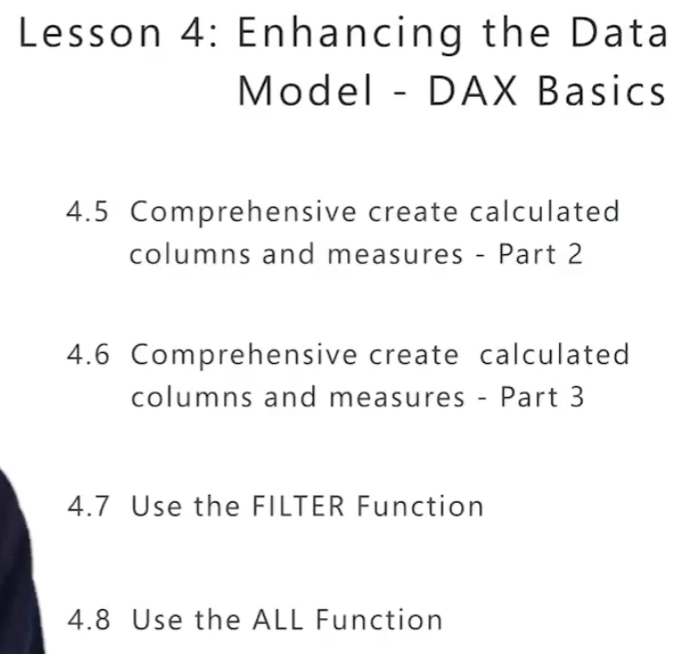

What is DAX :

DAX stands for Data Analysis Expressions. It is a functional language modeled after Excel formulas, making it familiar if you have used Excel expressions before. DAX is used to encapsulate business logic in your data model. It allows you to perform calculations such as concatenating names, calculating gross margin percentages, or year-over-year percentage changes. Essentially, DAX helps you create more complex and reusable calculations in Power BI.

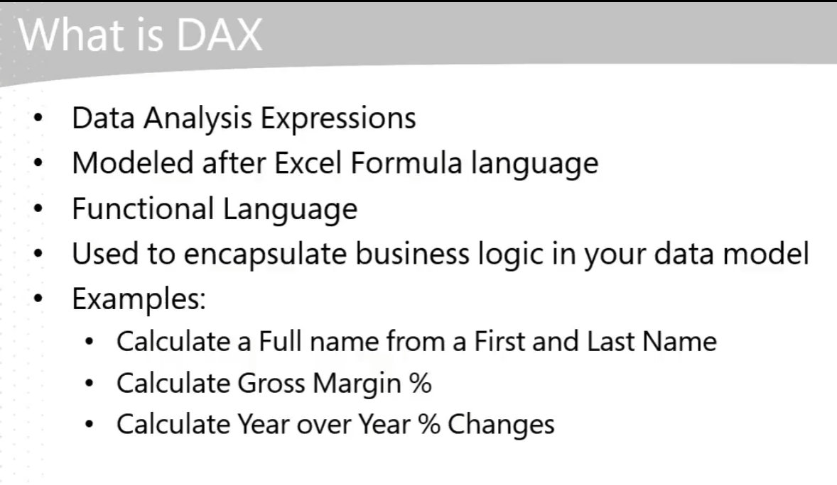

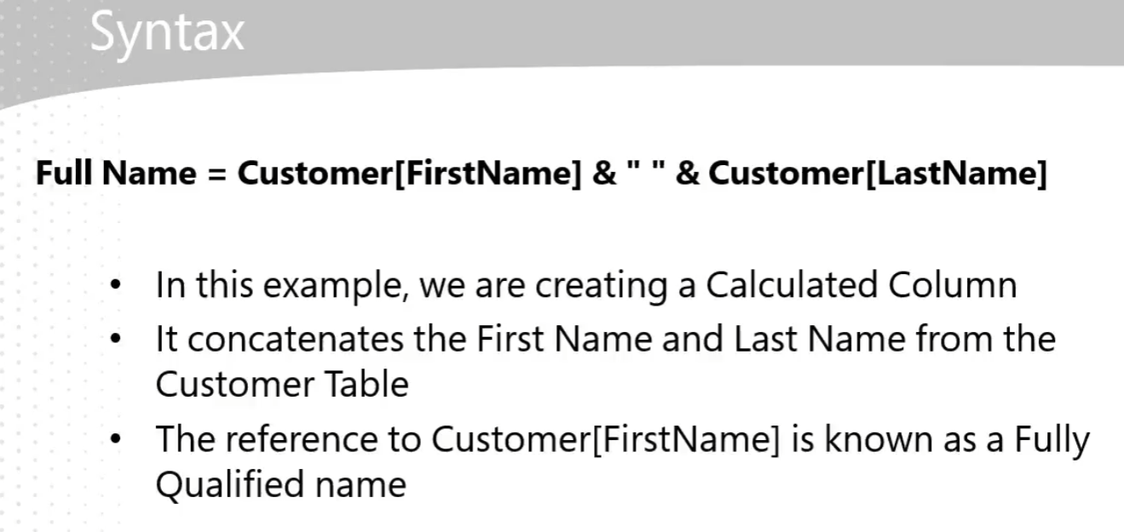

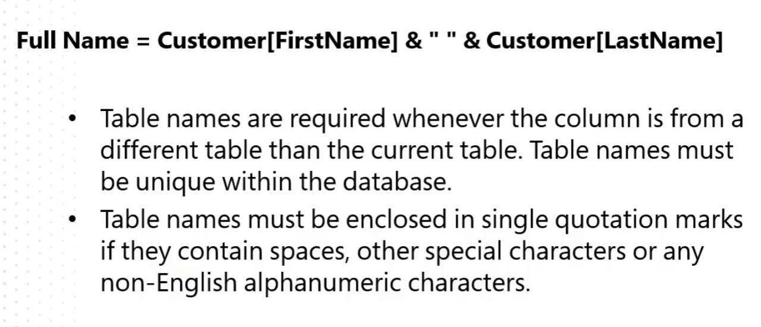

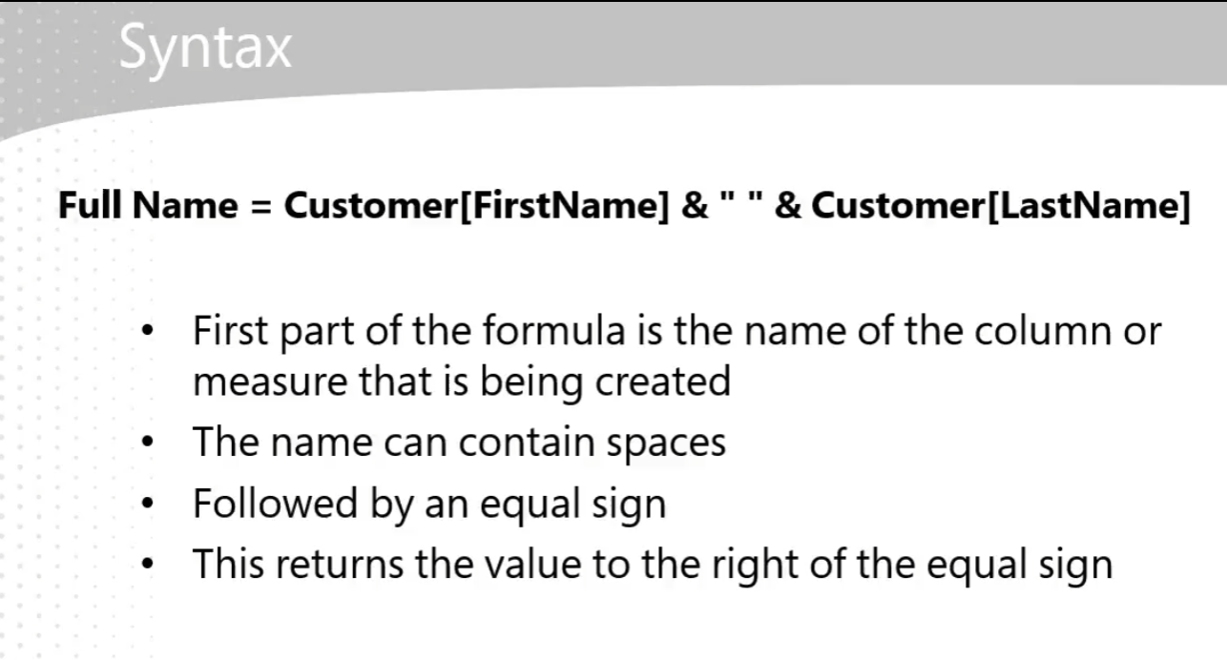

DAX (Data Analysis Expressions) is a functional language similar to Excel formulas. Here's a simplified breakdown of its syntax:

* **Column/Measure Name**: The name of the column or measure you are creating.
* **Equal Sign (=)**: Used to assign the result of the expression to the column/measure.
* **Expression**: The formula or calculation. For example, to concatenate first and last names from a customer table, you might write:  
  DAX  
  FullName = Customer[FirstName] & " " & Customer[LastName]
  + Customer[FirstName] and Customer[LastName] are fully qualified names, indicating the table and column.
  + The & operator is used to concatenate strings.
  + The space " " is added between the first and last names for readability.

Using table names in front of column names (e.g., Customer[FirstName]) makes the code more readable and improves performance. This practice helps both you and the engine understand where the data is coming from.  
  
In your role, understanding DAX syntax will help you create more advanced and reusable calculations in Power BI, enhancing your data analysis capabilities.

Send positive feedbackSend negative feedback

**Why learn DAX:**

*While default summarizations in Power BI are useful for basic aggregations (like sums, averages, min, max), learning DAX (Data Analysis Expressions) offers several key benefits:*

* *Complex Calculations: DAX allows you to perform more advanced calculations that go beyond basic aggregations, such as calculating year-over-year percentage changes or gross margin percentages.*
* *Reusability: DAX expressions can be reused in multiple calculations, making your data models more efficient and easier to maintain.*
* *Enhanced Performance: Explicitly writing DAX expressions can improve the readability and performance of your data models, as it avoids the need for the engine to infer default summarizations.*

*By learning DAX, you'll be able to unlock more powerful and flexible data analysis capabilities in Power BI, which can be particularly valuable in your role.*

*Including table names in DAX expressions offers several benefits:*

* ***Readability****: It makes the code more understandable. You can instantly see which table a column comes from, making it easier to read and maintain.*
* ***Performance****: It helps the Power BI engine process the expression faster by avoiding the need to determine the source table for each column.*
* ***Avoiding Confusion****: When columns from different tables are used, specifying the table name ensures clarity and prevents errors.*

*By explicitly stating the table name, you make your DAX expressions clearer and more efficient.*

1. Full Name = 'Customer data'[First Name] & " " & 'Customer data'[Last Name]

Difference b/w DAX and Measure:

* **DAX (Data Analysis Expressions)**: This is a functional language used in Power BI to perform calculations and data analysis. It is similar to Excel formulas and is used to create custom calculations and aggregations in your data model.
* **Measure**: A Measure is a specific type of calculation created using DAX. Measures are dynamic calculations that are evaluated based on the context of the data in your reports. They are typically used for aggregations like sums, averages, or more complex calculations.

In summary, DAX is the language you use to write calculations, and Measures are one of the types of calculations you can create using DAX.

Differences between measures and calculated columns (or calculated fields) in DAX:

* **Calculated Columns**:
  + Created in the data model and stored in the table.
  + Calculated row-by-row during data refresh.
  + Useful for creating new data fields based on existing columns (e.g., concatenating first and last names).
  + Example: FullName = [FirstName] & " " & [LastName].
* **Measures**:
  + Calculated on the fly during query time.
  + Not stored in the table, but used in visualizations.
  + Useful for aggregations and calculations that depend on the context of the report (e.g., total sales).
  + Example: Total Sales = SUM(Sales[LineTotal]).

Both are essential in Power BI for different purposes, and understanding when to use each can enhance your data analysis capabilities.

Send positive feedbackSend negative feedback

**4.2 Basic DAX Expressions:**

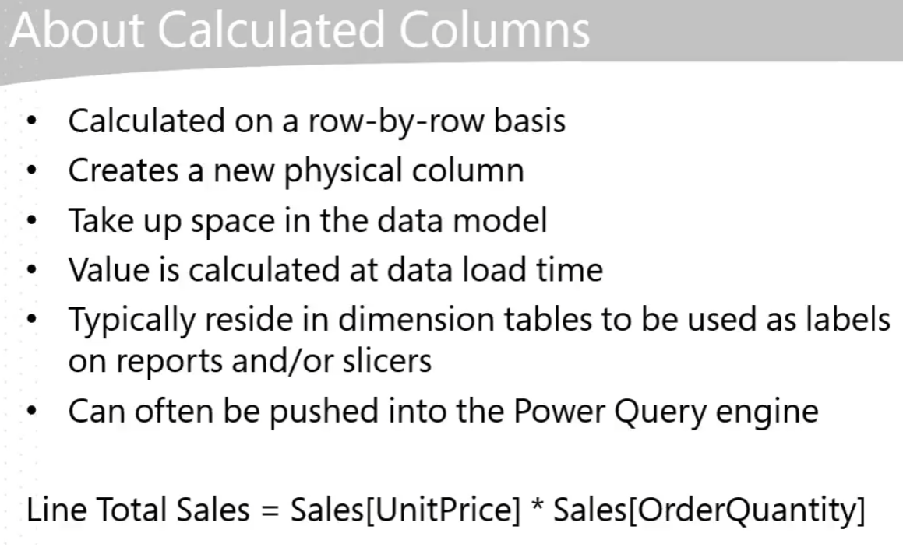

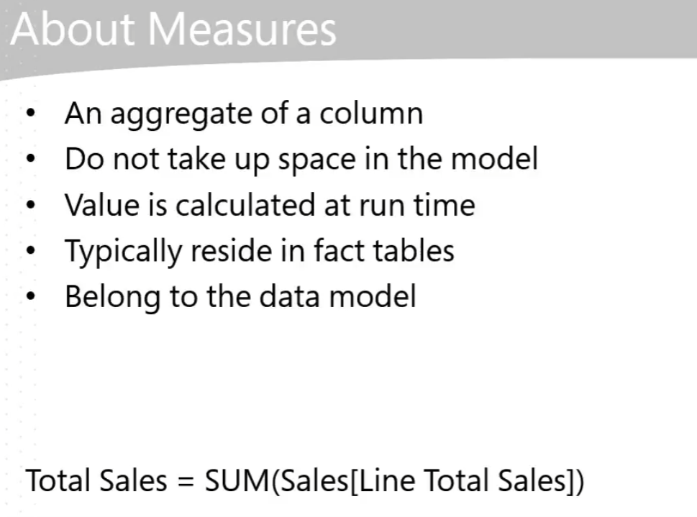

**Dimensional modeling** is a design concept used in data warehousing to structure data for efficient querying and reporting. Here’s a detailed explanation:  
  
What is Dimensional Modeling?

* **Dimensional modeling** organizes data into fact and dimension tables.
  + **Fact tables** store quantitative data for analysis and often include metrics like sales, revenue, or counts.
  + **Dimension tables** store descriptive attributes related to the facts, such as time, product, or customer details.

Key Concepts:

* **Star Schema**: The simplest form of dimensional modeling, where a central fact table is connected to multiple dimension tables.
* **Snowflake Schema**: A more complex form where dimension tables are normalized into multiple related tables.

Benefits:

* **Improved Query Performance**: Simplifies complex queries, making them faster and more efficient.
* **Ease of Use**: Makes it easier for business users to understand and navigate the data.
* **Scalability**: Facilitates the addition of new data without major restructuring.

Use in Power BI:

* **Simplifies DAX Expressions**: By organizing data into a star schema, DAX expressions are easier to write and understand.
* **Optimizes Data Models**: Ensures that data models are clean, with only necessary columns and rows, enhancing performance.

In the context of Power BI, dimensional modeling helps you create efficient and user-friendly data models, enabling you to build robust reports and dashboards.

Send positive feedbackSend negative feedback

Top of Form

Bottom of Form

Here are the pros and cons of using measures in Power BI as discussed in the video "Create basic DAX expressions":  
  
**Pros:**

* **Flexibility:** Measures are calculated at runtime, allowing users to build reports and slice and dice data as needed without relying on IT.
* **Efficiency:** Measures do not take up space in the data model, making them efficient in terms of storage.
* **Reusability:** Measures can be reused in other calculations, enabling more complex data analysis.

**Cons:**

* **Performance:** Since measures are calculated at runtime, they can run slowly if the data model is poorly designed or contains too much data.
* **Complexity:** Measures require a good understanding of DAX and the data model to ensure they are used effectively and efficiently.Top of Form

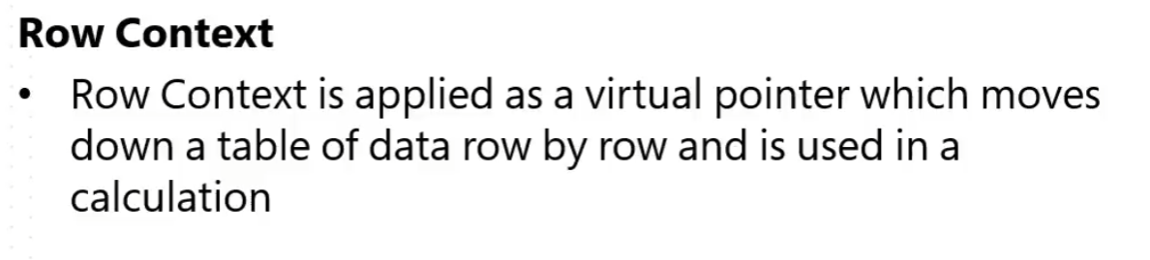

*Row context refers to the context that is applied as a virtual pointer, which moves down a table of data row by row and is used in a calculation. Essentially, it allows DAX to evaluate each row individually when performing calculations.  
In the video, it's explained that when you create a calculated column, such as a Full Name column by concatenating first and last names, DAX processes each row one at a time. For example, it takes the first name and last name from the first row, combines them, then moves to the next row and repeats the process.  
This row-by-row evaluation is crucial for creating calculated columns and performing operations that depend on individual row values.Bottom of Form*

Top of Form



*Filter context in DAX refers to the set of filters that are applied to a DAX expression to determine its result. It is crucial for understanding how DAX calculations are influenced by the data being filtered in your Power BI reports.*

* ***Definition****: Filter context is the context that is applied by taking all the filters that surround a DAX expression and then applying them to affect its result.*
* ***Usage****: It allows you to apply filters at different levels (visual, page, or report) to control how data is displayed and calculated. For example, you can filter data by year, product category, or any other dimension to see specific results.*

*In the video, it is demonstrated how filter context can be applied at different levels (visual, page, and report) to influence the outcome of DAX expressions. This helps in creating dynamic and interactive reports where users can slice and dice data according to their needs.*

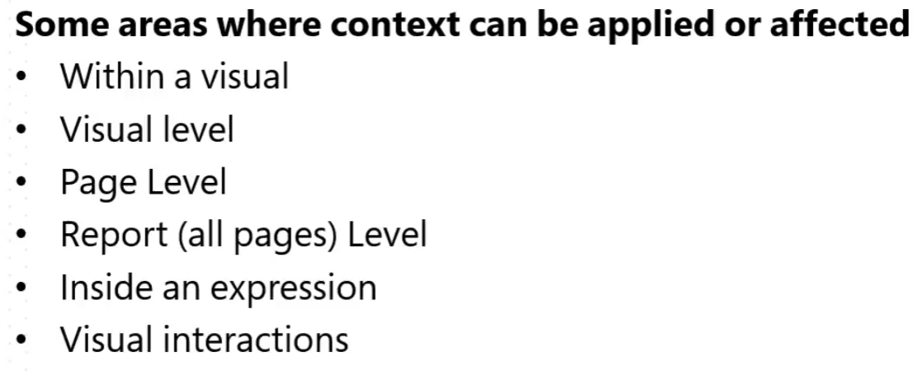

Bottom of Form

*In the video "Create basic DAX expressions," the term "context" refers to two main concepts in DAX:*

1. *Row Context: This is the context applied as a virtual pointer that moves down a table of data, row by row, and is used in a calculation. For example, when creating a calculated column, the row context processes each row individually to perform the calculation.*
2. *Filter Context: This context is applied by taking all the filters surrounding a DAX expression and applying them to affect its result. Filters can be applied at different levels, such as visual, page, or report level, and they influence the data shown in your visuals.*

*These contexts help determine how DAX expressions are evaluated and how data is filtered and calculated in Power BI.*

**Pbix File:**

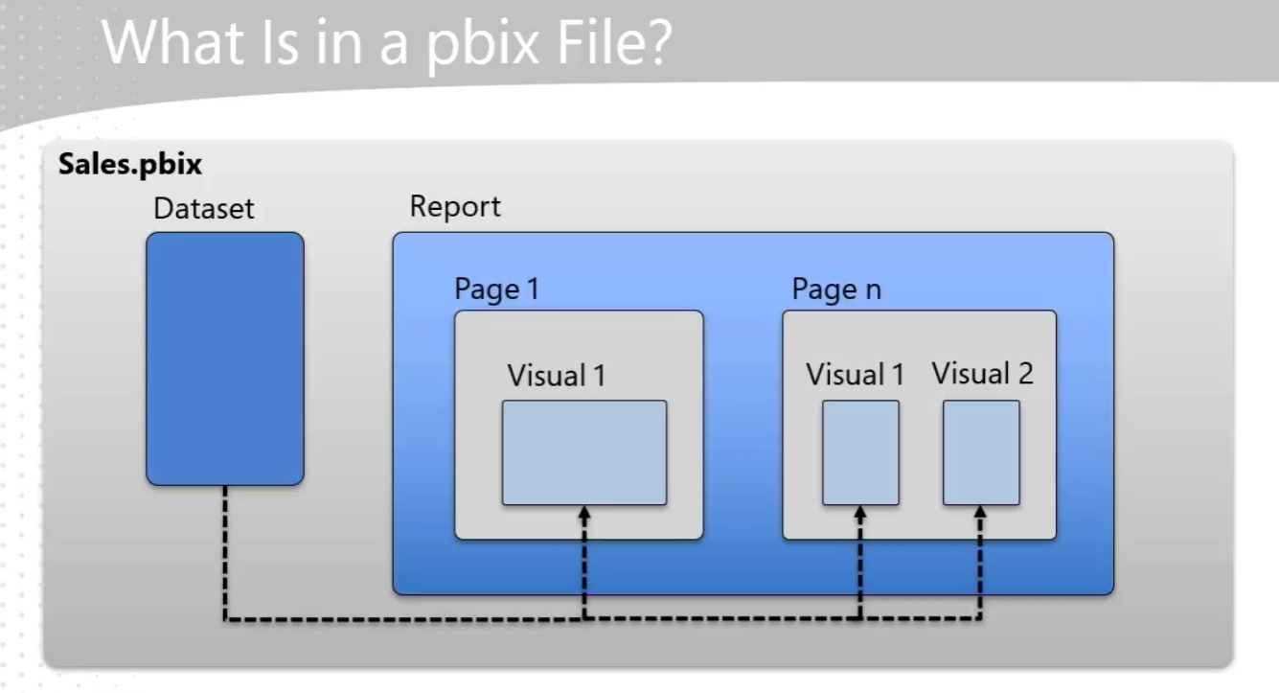

* **PBIX File Structure**: A PBIX file is essentially a Power BI project file that contains both the data set and the report. When you create and save your work in Power BI Desktop, it gets saved as a PBIX file.
* **Components**:
  + **Data Set**: This part of the PBIX file includes all the data you have imported and transformed using Power Query. It also contains the data model, which includes tables, relationships, and any calculated columns or measures created using DAX.
  + **Report**: This part contains the visualizations you create, such as charts, tables, and other visuals. A report can have multiple pages, and each page can have multiple visuals.
* **Separation of Data Set and Report**: One of the key architectural advantages of Power BI is the separation of the data set and the report within the PBIX file. This allows for efficient data management and reporting.
* **Filters**: Filters can be applied at different levels within the PBIX file:  
    
  + **Report Level**: Filters that affect all pages in the report.
  + **Page Level**: Filters that affect only a single page.
  + **Visual Level**: Filters that affect only a single visual.
* **Publishing**: When you publish a PBIX file to the Power BI service, the data set and report are separated. This allows for better management and sharing of data and reports.

This structure helps in organizing your work efficiently and ensures that your data and visualizations are well-integrated.

Top of Form

4.3 LOGICAN EXPRESSIONS IN DAX:

**2. Primary Buyer = AND('Customer data'[Cars Owned] = 0,'Customer data'[Home Owner] = "No")**

**3. Secondary Buyer = OR('Customer data'[Cars Owned] = 0, 'Customer data'[Home Owner] ="No")**

**4. Color Category = IF('Product'[Color] IN {"Black","Blue","Red"},"Darker","Lighter")**

1. **AND Function**:
   * **Equation**: *IF(Cars Owned = 0 && Customer Home Owner = "No", "Primary Buyer", "Not Primary Buyer")*
   * **Explanation**: This equation creates a new column called "Primary Buyer". If both conditions (Cars Owned equals 0 and Customer Home Owner equals "No") are true, it returns "Primary Buyer". Otherwise, it returns "Not Primary Buyer". The && operator is used to combine the two conditions.
2. **OR Function**:
   * **Equation**: *IF(Cars Owned = 0 || Customer Home Owner = "No", "Secondary Buyer", "Not Secondary Buyer")*
   * **Explanation**: This equation creates a new column called "Secondary Buyer". If either condition (Cars Owned equals 0 or Customer Home Owner equals "No") is true, it returns "Secondary Buyer". Otherwise, it returns "Not Secondary Buyer". The || operator is used to combine the two conditions.
3. **IN Function**:
   * **Equation**: *IF(Product Color IN {"Black", "Blue", "Red"}, "Darker Color", "Lighter Color")*
   * **Explanation**: This equation creates a new column called "Color Category". If the Product Color is either "Black", "Blue", or "Red", it returns "Darker Color". Otherwise, it returns "Lighter Color". The IN operator is used to check if the Product Color matches any of the specified values.

These logical expressions are essential for categorizing and filtering data based on specific business rules, which is a key part of your role in data analysis. Top of Form

**4.4 Comprehensive Create Calculated Columns and Measures Patr 1:**

**5. Line Product Cost = Sales[Order Quantity]* RELATED('Product'[Standard Cost])**

Using measures instead of calculated columns in Power BI has several advantages:

* **Performance**: Measures are calculated on the fly and are more efficient, especially with large datasets, as they do not store values in the data model.
* **Flexibility**: Measures are more dynamic and can adapt to different contexts in your reports, allowing for more versatile data analysis.
* **Best Practices**: As you advance in DAX, you'll find measures to be more powerful and aligned with best practices for building scalable and maintainable models.

In your role, leveraging measures can enhance your ability to create insightful and efficient reports.

Bottom of Form

Related Function:

The **"Related"** function in Power BI is used to fetch values from a related table. Here's a detailed explanation:

* **Purpose**: The "Related" function allows you to access data from another table that has a relationship with the current table. This is particularly useful when you need to use data from a different table to create calculated columns or measures.
* **How it works**: The function works by navigating the relationship between tables. It requires a many-to-one relationship between the tables. For example, if you have a sales table and a product table, you can use the "Related" function to bring in product details into the sales table.
* **Example from the video**: In the video, the presenter creates a calculated column called "line product cost" in the sales table. The expression used is:  
  DAX  
  line product cost = Sales[Order Quantity] * RELATED(Product[Standard Cost])  
    
  Here, the "Related" function retrieves the "Standard Cost" from the product table for each row in the sales table, using the existing relationship between the sales and product tables.
* **Key Points**:
  + The "Related" function only works if there is an existing relationship between the tables.
  + It is used to perform calculations that require data from multiple tables.
  + It simplifies the process of combining data from different tables into a single calculation.

This function is essential for creating accurate and comprehensive data models in Power BI, especially when dealing with complex datasets.

*[Default summarization in Power BI refers to the automatic aggregation method applied to a column when it is used in a visual. For example, when you drag a numeric column like "line total sales" onto a visual, Power BI will automatically sum the values in that column. This default behavior can be changed to other aggregation methods like average, minimum, maximum, or count, depending on your needs.  
  
In the video, it is mentioned that default summarization is used to sum up values in columns like "line total sales" and "line product cost" to show total values across different years. You can adjust this summarization method by selecting the column in the visual and changing the aggregation type from the dropdown menu.]*

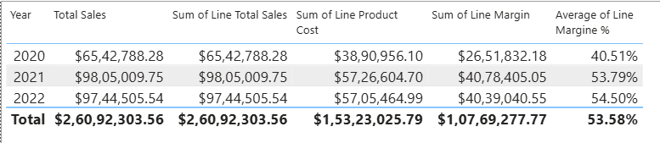

*Here the average of the line margin percentage is incorrect because the order of operations is not being handled properly. When you sum up the line margins and then average them, it doesn't reflect the true margin percentages. Instead, you should use measures to ensure the calculations are accurate. The video suggests leveraging measures rather than calculated columns to get the correct results. This way, the calculations are performed in the correct order, providing accurate margin percentages.*

* 1. **Comprehensive Create Calculated Columns and Measures Patr 2:**

**6. Total Margin = SUM(Sales[Line Margin])**

Key Takeaways from the Video:

* **Creating Measures:** The video demonstrates how to create measures in Power BI to solve specific problems, such as calculating total margin and total margin percentage.
* **Formatting Measures:** Emphasis is placed on properly formatting measures for readability and accuracy.
* **Layering Measures:** Simple measures can be used to build more complex measures, promoting maintainability and clarity in your data models.

Explanation of the Measure Equation:

1. **Creating Total Margin Measure:**
   * The measure Total Margin is created using the SUM function to sum up the Line Margin column.
   * Example: Total Margin = SUM(Sales[Line Margin])
2. **Creating Total Margin Percentage Measure:**
   * The measure Total Margin Percentage is created by dividing the Total Margin measure by the Total Sales measure using the DIVIDE function.
   * Example: Total Margin Percentage = DIVIDE([Total Margin], [Total Sales])
   * This ensures safe division, handling any divide-by-zero errors.
3. **Formatting:**
   * Measures are formatted appropriately, such as setting Total Margin Percentage as a percentage for better readability.

These steps help ensure that the calculations are accurate and maintainable, allowing you to build more complex measures over time.

The key difference between the Average of Line Margin and Total Margin Percentage lies in how they are calculated and what they represent:

* **Average of Line Margin**: This is the average margin calculated for each individual line item. It sums up the margins for all line items and then divides by the number of line items. This can sometimes lead to misleading results because it doesn't account for the relative size of each sale.
* **Total Margin Percentage**: This is calculated by first summing up the total margin and total sales, and then dividing the total margin by the total sales. This method ensures that the calculation takes into account the overall sales volume, providing a more accurate representation of the margin percentage.
  1. **Comprehensive Create Calculated Columns and Measures Patr 3:**

Moving away from calculated columns to measures in Power BI is recommended because:

* Efficiency: Measures are calculated on the fly, which can improve performance, especially with large datasets.
* Flexibility: Measures can adapt to different contexts and filters applied in your reports, providing more dynamic and accurate results.
* Best Practices: Using measures aligns with best practices for building scalable and maintainable data models.

This approach helps you build more efficient and flexible production models.

The **SUMX** function in Power BI is a DAX (Data Analysis Expressions) function that iterates over a table and evaluates an expression for each row, then returns the sum of those values. Here's a breakdown of how it works:

1. **Table**: The first argument is the table you want to iterate over.
2. **Expression**: The second argument is the expression to evaluate for each row in the table.

In the video, the equation used is:  
DAX  
Total Sales SUMX = SUMX(Sales, Sales[Quantity] * Sales[Unit Price])

* **Sales**: This is the table being iterated over.
* **Sales[Quantity] * Sales[Unit Price]**: This is the expression evaluated for each row. It multiplies the quantity by the unit price for each row in the Sales table.

The SUMX function then sums up these calculated values for all rows in the table, providing the total sales amount.  
This approach helps in calculating values dynamically, making your data model more efficient and flexible.

**7.Top of Form SUMX = SUMX(Sales,Sales[Unit Price]*Sales[Order Quantity])**

* 1. **: Using FILTER Function**

The FILTER function in DAX is used to return a table that represents a subset of another table, filtered by a specified condition. Here's how it works:

* Syntax: FILTER(<table>, <filter_expression>)
  + <filter_expression>: The condition that each row must meet to be included in the result.
  + **The table you want to filter. In the video, the FILTER function is used to filter the sales table to include only rows where the line total sales are greater than 50. Here's an example from the video:DAXCount of Sales Orders Line Items Greater Than 50 =COUNTROWS(FILTER(Sales,Sales[Line Total Sales] > 50))This function first reduces the sales table to only those rows where the line total sales are greater than 50. Then, the COUNTROWS function counts the number of rows in this filtered table.The FILTER function is powerful for creating dynamic subsets of data based on specific conditions, making your analyses more precise and tailored to your needs.**

**DAX Functions Used:**

1. COUNTROWS:  
   * Purpose: Counts the number of rows in a table.
   * Usage in Video: Used to count the number of sales order line items in the sales table.
   * Example: Count of Sales Order Line Items = COUNTROWS(Sales)
2. SUM:  
   * Purpose: Adds up all the numbers in a column.
   * Usage in Video: Used to sum values in a column, depending on the data structure.
   * **Example**: SUM(Sales[Line Total])
3. **DISTINCTCOUNT**:
   * **Purpose**: Counts the number of distinct values in a column.
   * **Usage in Video**: Used to count the number of distinct sales order numbers.
   * **Example**: Count of Sales Orders = DISTINCTCOUNT(Sales[Sales Order Number])
4. **FILTER**:
   * **Purpose**: Returns a table that represents a subset of another table, filtered by a specified condition.
   * **Usage in Video**: Used to filter the sales table to include only rows where the line total sales are greater than 50.
   * **Example**:  
     DAX - Count of Sales Orders Line Items Greater Than 50=COUNTROWS(FILTER(Sales,Sales[Line Total Sales] > 50))
5. **Count of Sales Order Line Items GT 50 = COUNTROWS(FILTER(Sales,Sales[Line Total Sales]>50))**

Bottom of Form

Top of Form

Bottom of Form

Things I need to look in to in the Later Stage:

1. Merging of Tables
2. Creating Hirarchy and its uses
3. Filters (on Full Dashboard, Single Page, A Particular Graph)
4. Related function